* TestNG and JUnit are Java Frameworks.
* Initially JUnit was used a lot.
* There are very limited features in JUnit compared to TestNG.
* In Junit you may need to write lengthy codes.
* TestNG can be used for Selenium, Appium, Rest Assured API Testing.
* Here we will discuss about TestNG in details.
* TestNG helps to convert piece of selenium codes into Test Cases.
* Open Eclipse and download the latest version of testing. Don’t download beta versions.
* Create a maven project.
* File > New> Project>Maven Project> Click create a simple project >Next

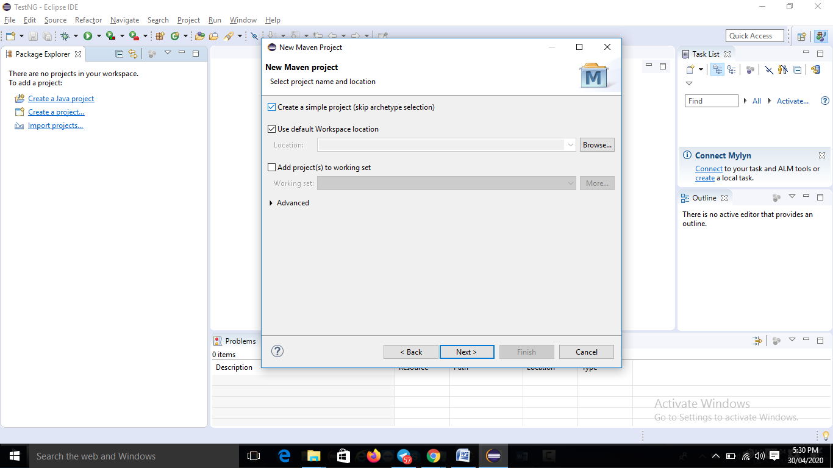

* Under <Dependencies> tag provide TestNG Maven dependency.

<dependency>

<groupId>org.testng</groupId>

<artifactId>testng</artifactId>

<version>7.1.0</version>

<scope>test</scope>

</dependency>

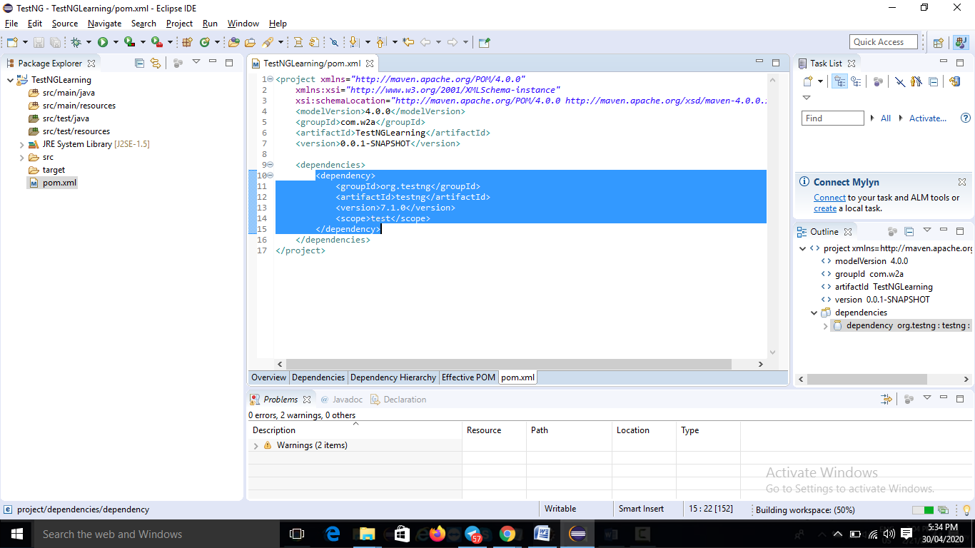

* You can download TestNG plugin also.



